Linked Lists
- Data is visualized in a linear manner like in arrs & arrlists. Although there isn’t any continuous memory allocation.
A chain of els is formed. 2 els are connected thr u a link & the els are called nodes.
- Node has 2 parts – Data(variable of Primitive type and it stores some info(Primitive value). Ex- integer value, boolean value, etc)
Next(reference variable that stores the address of the next node(object) and so a link can be visualized)
- Like this after a series of nodes the last node’s next stores null(a special empty value that represents the absence of an object reference)
- Ref. variables point to an object. So here nodes are the objects. We have to make a class Node(blueprint of these objects).
- The data type of Next will be complex data type(Node type)
- We can define constructor in class node :
public static class Node{//class having 2 properties(member variables) – data, next
int data; //a primitive variable in stack memory which can hold a value
Node next;//a ref. variable in stack memory which can hold addresses of objects of Node class
public Node(int data){//constructor for initializing an object with these vals.
this.data=data;//data assigned to the data property of class Node
this.next=null;//initialized to null, not pointing to anything
}
}
Node newNode = new Node(data); // this statement creates an object in the heap memory. newNode is the ref. var in stack memory which will be given the address of that object
- Java provides a default constructor but that cannot initialize the data field. So we have to create a constructor explicitly. Without this constructor, you would need to manually set the values every time a Node is created, which is inefficient.
- To track any info in linked list we need 2 special nodes – Head Node(first node of ll), Tail Node(last node of ll). They are ref. vars capable of holding addresses of node objects.
- In a ll with single node both head and tail hold the address of the node and next stores null.
- Operations on Linked List
i) add to First :
1. Create a new node Node newNode = new Node(data);
2. If linked list is empty
if (head==null){
head=tail=newNode;
return;
}
3. If linked list is not empty
newNode.next = head;
head = newNode;
Time Complexity = O(1) {Constant Time Complexity}
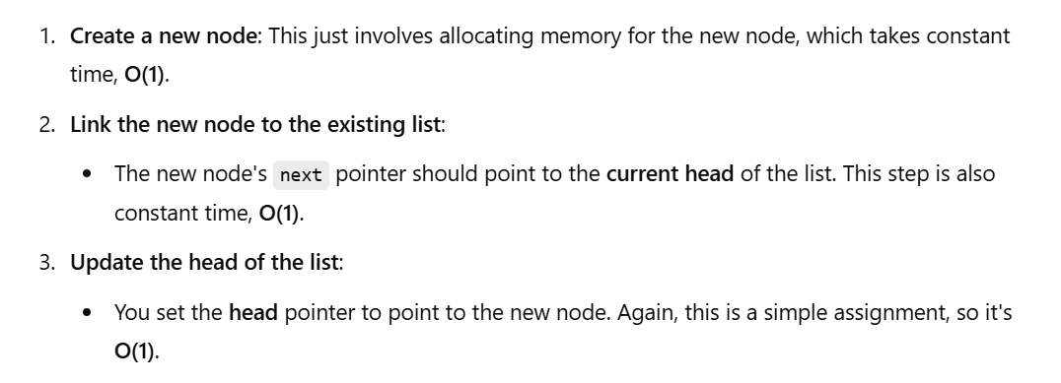
ii) add to Last :
1. Create a new node Node newNode = new Node(data);
2. If linked list is empty
if (head==null){
head=tail=newNode;
return;
}
3. If linked list is not empty
tail.next = newNode; //last node’s next stores the address of newNode
tail = newNode; //tail stores the address of newNode
Time Complexity = O(1) {Constant Time Complexity}
iii) print Linked List :
1. Use a temporary variable temp = head
2. if (head==null){
syso(“List is empty”);
return;
}
while (temp != null){
syso(temp.data+“->”);
}
Time Complexity = O(n) {Linear Time Complexity} since this function goes to every single node of linked list
iv) add in Middle :
In arrays to insert and delete elements at/from(beginning,middle,end) we need to create a new array of new size and copy its elements to it. In case of ArrayList it automatically resizes itself and elements are automatically shifted when we insert or remove elements at specific positions. We don't need to manually shift the elements.
This copying and shifting operation is not needed in Linked List. We just need to change the references of the reference variables(pointers) that’s it. But still adding node in the middle has TC = O(n) because time is taken to find the index which is not taken in arrays and arraylists. n operations are needed to find the index as there are n nodes so TC = O(n). But the linkage process takes constant time O(1). So overall O(n). In arrays the copy step takes O(n) time while the index is already known.
1. Create a new node Node newNode = new Node(data);
2. If list is non-empty and we want to insert at idx 0 or if list is empty
if (idx==0){
addFirst(data);
return;
}
3. If linked list is not empty
tail.next = newNode; //last node’s next stores the address of newNode
tail = newNode; //tail stores the address of newNode
Time Complexity = O(1) {Constant Time Complexity}

Merge Sort on Linked List
- If ll is even – mid node is last node of first half

